**Introducing the NERLYFE study**: **a post-approval safety study of neratinib in the extended adjuvant setting**

Dear Doctor,

Pierre Fabre is collaborating with Covance to execute an observational post-approval safety study (PASS*), for which we are seeking for your possible collaboration.

Neratinib (Nerlynx®) is an orally available tyrosine kinase inhibitor, currently approved in the European Union as extended adjuvant treatment of adult patients with early-stage hormone receptor positive HER2-overexpressed/amplified breast cancer who completed adjuvant trastuzumab-based therapy less than one year ago.

The European Medicines Agency (EMA) requested to Pierre Fabre to perform the additional pharmacovigilance activities including this European, prospective, observational PASS depicted below.

This international project is very important since it will highly support to characterize the safety profile of neratinib in the real-world setting. In addition, findings from this PASS will be crucial for the use of neratinib and the treatment management in the current clinical practice.

**Study design:**

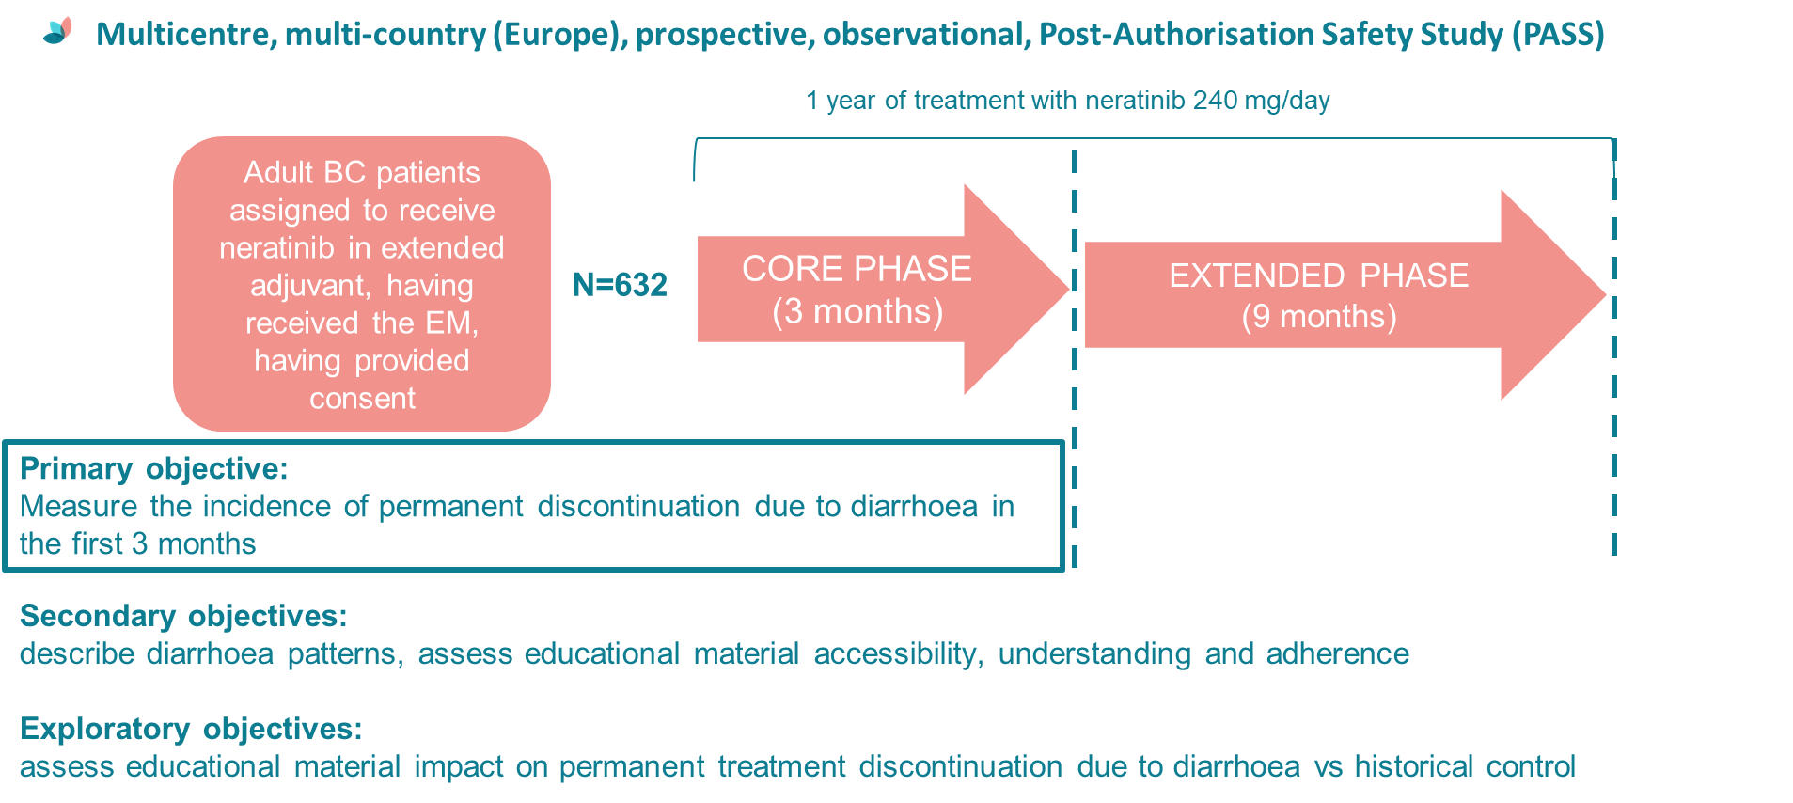

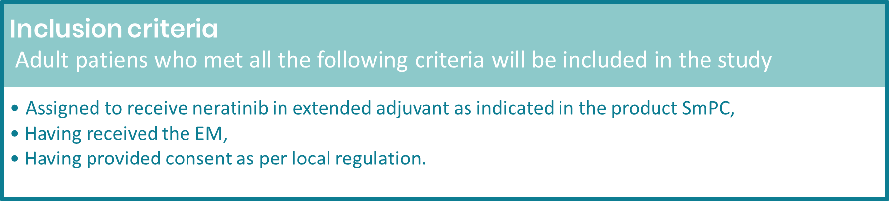

* A PASS S, a study that is carried out after a drug receives the marketing authorization in order to obtain further information on its safety, or to measure the effectiveness of risk-management measures in a real world setting.

In terms of time spent, this study will be performed under conditions of routine clinical practice and will not interfere with any aspect of the patient clinical management. All patients will be treated and monitored according to the local clinical practice. No additional procedures other than those listed in the product SmPC and no additional visits other than those planned for the usual clinical practice will apply.

If you are interested in joining this key international research project, please let us know by completing the online questionnaire via the QR code or the link below.

<http://covance.Final-Abbr-Survey-Study-Neratinib-Adult-Patients-Breast-Cancer.alchemer.com/s3/>

Please be informed that working hours spent by staff involved on this upcoming study, including this survey completion, and other related costs will be compensated by the sponsor. Further details can be discussed later after your survey completion.

**The online survey should take no more than 10-15 minutes to complete**. Once we have received your feedback, we are happy to provide you with more detailed information.

Thank you for your time!

Kind regards

**Roberta Valenti**

Breast Cancer Medical Director

Medical Affairs Oncology

Pierre Fabre Médicament